

<Insert Customer Logo Here>

HOME OFFICE DIGITAL, DATA AND TECHNOLOGY TESTING SERVICES MANAGED DOCUMENTATION PRODUCT

Instructions:
<Text> = EDIT or DELETE as required

<PROJECT>
TEST COMPLETION REPORT

Document Version | <n.n>
Issued Date | <dd/mm/yyyy>
Approved Date | <dd/mm/yyyy>
Author | <Author>
Owner | <Owner>
Status | <Draft / Approved>
Security Classification | <Official>



Template Reference: HOIT-Test-TEM-004
Template Version: 2.5

Purpose of this Document

This document details a summary of the test activities, results and recommendations of the Home Office Digital, Data and Technology Test Design and Consultancy Services Test Team in respect of the UAT conducted for <PROJECT>

Document Location

F:\BISTD UAT\Test Design and Consultancy Services Products\Templates

Revision History
Date of Issue | Author | Version | Status
<dd/mm/yyyy> | <Author> | <n.n> | <Status>

Approval for Release

This document requires the following approvals before it can be issued for release:
Name | Position / Title | Date of Approval
<Name> | <Position / Title> | <dd/mm/yyyy>
<Name> | <Position / Title> | <dd/mm/yyyy>

Approval for Sign-Off

This document requires the following approvals to be deemed as signed-off:
Name | Position / Title | Date of Approval
<Name> | <Position / Title> | <dd/mm/yyyy>
<Name> | <Position / Title> | <dd/mm/yyyy>

Circulation List
Name | Position / Title | RACI*
<Project Manager> | <Project Manager - Authority> | <RACI>
<Senior Business Representative> | <Senior Business User> | <RACI>
<Project Manager> | <Project Manager – Supplier> | <RACI>
* R = Responsible / A = Accountable / C = Consulted / I = Informed

References & Supporting Documentation
Ref | Document Title | Author | Date of Issue | Version
1 | <Your UAT Test Plan> | <Author> | <dd/mm/yyyy> | <n.n>

Table of Contents

1 Introduction 4
2 UAT Objectives 4
3 Test Scope 5
4 Test Configuration 5
5 Entry / Exit 6
6 Summary of Activities 7
7 Summary of Results 10
8 Graphical Summary of Defects Raised 11
9 Workarounds 13
10 Residual Risks & Recommendations 13
11 Abbreviations 14
12 Annex A – Summary of Results 15
13 Annex B – UAT Defect Log 15
14 Annex C – Detailed Test Scope 16

Introduction

<Concise summary from Test Plan (ensure correct tense is utilised)>

UAT test activities were conducted in this regard between <START dd/mm/yyyy> and <END dd/mm/yyyy> over <x> cycles of testing. This report provides a summary of these test activities, presentation and analysis of the test results and highlights any residual risks together with specific recommendations in respect of live deployment.

UAT Objectives

The following UAT objectives in respect of the <PROJECT> were defined in the UAT Test Plan [1];

- Exercise systems in a way that is reflective of how end users will use the production system;

- Assess the extent to which the product meets the specified business/user requirements;

- Assess the extent to which the product is ‘fit for purpose’;

- Identify, report, track and summarise ‘defects’ (deviations from expectation) for stakeholder review at the Defect Review Board;

- Provide timely, accurate and factual information to the project / programme to facilitate a release decision;

- <Copy remaining objectives from the Test Plan>

<State whether all of the objectives were met. If not, provide a concise explanation>

Test Scope

The following items were deemed within scope of UAT as defined in the UAT Test Plan [1]:

Functional aspects

<copy from Test Plan as appropriate> - justify deviations (if any)>

Non-functional aspects

<copy from Test Plan as appropriate> - justify deviations (if any)>

Business Processes/Procedures

<copy from Test Plan as appropriate> - justify deviations (if any)>

Items/Features not to be tested in UAT
3.5.1 <copy from Test Plan as appropriate> - justify deviations (if any)>

The following requirements have been deemed out of scope of UAT;
3.6.1 <copy from Test Plan as appropriate> - justify deviations (if any)>

For the detailed test scope breakdown by requirement reference please refer to Annex C.

Test Configuration

The following software was installed and tested in the UAT environment:
Application | Initial Version | Final Version | Code Iterations | Test Environment | Supplier
<Application> | <N.n.n> | <N.n.n> | <x> | <Environment> | <Supplier>

< When populating this table, consider whether:

- All UAT testing was conducted on a single environment or were some tests executed on other test environments?

- There was more than one distinct application under test – for example, end-to-end testing of interfaces with multiple suppliers? >

UAT was carried out against all code iterations <edit this if not true for your project>

Entry / Exit

UAT Entry Criteria
Description | Criterion Met (Y/N) | Comments
<Copy all applicable Entry Criteria from UAT Quality Gate Checklist (HOIT-Test/TEM/024) – one per row> | <Y/N> | <Comment if not met>

UAT Exit Criteria
Description | Criterion Met (Y/N) | Comments
<Copy all applicable Exit Criteria from UAT Quality Gate Checklist (HOIT-Test/TEM/024) – one per row> | <Y/N> | <Comment if not met>

Summary of Activities

The following table summarises all UAT test execution activities in chronological order, conducted for this project:
Planned Start / End [days] | Actual Start / End [days] | Description | Test Env + Code Version | Notes
<dd/mm/yyyy>  <dd/mm/yyyy>  <[n days]> | <dd/mm/yyyy>  <dd/mm/yyyy>  <[n days]> | Confidence Testing  <Enter brief description, for example>  Create test data and execute confidence tests to verify environment and application build. | <Env>  <N.n.n> | Issues / Concerns / Delays  <List observations (not application defects) related to what did not go according to plan, for example, were any delays encountered, deployment issues, requirement changes, application availability, environmental issues, technical difficulties, quality of testing concerns etc…>  General Progress  <Did all tests within this period start and complete on time? If not why not? Were a specific set of scripts executed in this period?>
<dd/mm/yyyy>  <dd/mm/yyyy>  <[n days]> | <dd/mm/yyyy>  <dd/mm/yyyy>  <[n days]> | Data Migration Testing  <Enter brief description, for example  Create test data for data migration testing against the release ...  Backup and migrate test data...  Execute data migration tests against release ...> | <Env>  <N.n.n> | Issues / Concerns / Delays  <List observations (not application defects) related to what did not go according to plan, for example, were any delays encountered, deployment issues, requirement changes, application availability, environmental issues, technical difficulties, quality of testing concerns etc…>  General Progress  <Did all tests within this period start and complete on time? If not why not? Were a specific set of scripts executed in this period?>
<dd/mm/yyyy>  <dd/mm/yyyy>  <[n days]> | <dd/mm/yyyy>  <dd/mm/yyyy>  <[n days]> | UAT Execution Cycle 1  <Enter brief description, for example>  Execute full set of test scripts including regression.  Users Involved: up to 3 per day> | <Env>  <N.n.n> | Issues / Concerns / Delays  <List observations (not application defects) related to what did not go according to plan, for example, were any delays encountered, deployment issues, requirement changes, application availability, environmental issues, technical difficulties, quality of testing concerns etc…>  General Progress  <Did all tests within this period start and complete on time? If not why not? Were a specific set of scripts executed in this period?>
<dd/mm/yyyy>  <dd/mm/yyyy>  <[n days]> | <dd/mm/yyyy>  <dd/mm/yyyy>  <[n days]> | Data Preparation – UAT Cycle 2  <Enter brief description, for example>  Database schema changes prevented migration of Cycle 1 test data to new build. | <Env>  <N.n.n> | Issues / Concerns / Delays  <List observations (not application defects) related to what did not go according to plan, for example, were any delays encountered, deployment issues, requirement changes, application availability, environmental issues, technical difficulties, quality of testing concerns etc…>  General Progress  <Did all tests within this period start and complete on time? If not why not? Were a specific set of scripts executed in this period?>
<dd/mm/yyyy>  <dd/mm/yyyy>  <[n days]> | <dd/mm/yyyy>  <dd/mm/yyyy>  <[n days]> | UAT Execution Cycle 2  <Enter brief description, for example>  Re-test high priority defects & execute targeted regression tests  Users Involved: up to 3 per day | <Env>  <N.n.n> | Issues / Concerns / Delays  <List observations (not application defects) related to what did not go according to plan, for example, were any delays encountered, deployment issues, requirement changes, application availability, environmental issues, technical difficulties, quality of testing concerns etc…>  General Progress  <Did all tests within this period start and complete on time? If not why not? Were a specific set of scripts executed in this period?>

Summary of Results

Outstanding high severity and/or priority defects are as follows:
Defect Ref | Date Raised | Description | DRB Agreed Action(s) | Severity/Priority
<Defect Ref> | <dd/mm/yyyy> | <Succinct description including business impact> | <Action(s) agreed at DRB(s) for resolving defect> | <1 / 1>

<Report on the overall status of defects. Focus should be on trends / patterns and cause(s) where possible – for example, consider whether:
- Usability issues were more prevalent than functional?

- Certain high severity and/or priority defects can be categorised or grouped?

- Any product risks identified during planning / design phases manifested and whether they remain outstanding (if outstanding please detail at section 10)?

- A higher number than expected regression defects were encountered?

- The defects raised can demonstrate reasonable grounds for concern with respect to new functionality?

- New potential security concerns have been introduced?

- End-to-End processes are now more complicated, less user friendly and more inefficient?

- Etc…>

The following table provides a summary of tests planned grouped by final status:
Total Test Scenarios | No. | %
<Copy from test summary tab within UAT Execution Management Log>
No Of Scenarios
No Of Scenarios Executed
No Of Scenarios In Progress
No Of Scenarios Passed
No Of Scenarios Conditionally Passed
No Of Scenarios Blocked
No Of Scenarios Void
No Of Scenarios Failed

Further details, including logging of pass/fail against each scenario executed can be found at Annex A.

Graphical Summary of Defects Raised

The following graphs provide an overview of the defects raised during UAT:
<The following graph types must be included in this report for completeness (taken from the dashboard within the UAT Execution Management Log (HOIT-Test/TEM/006))>
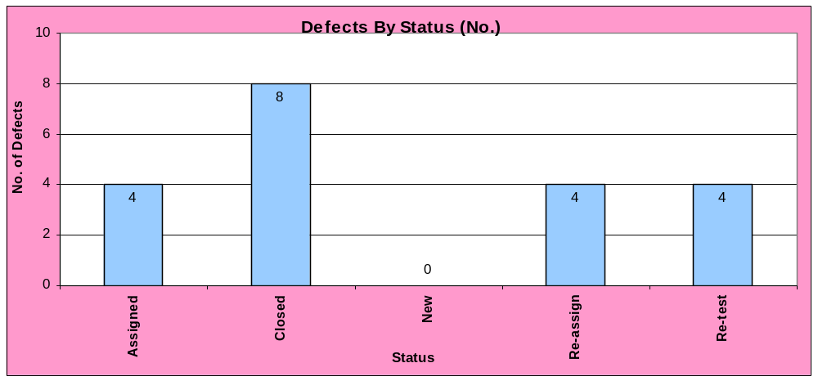

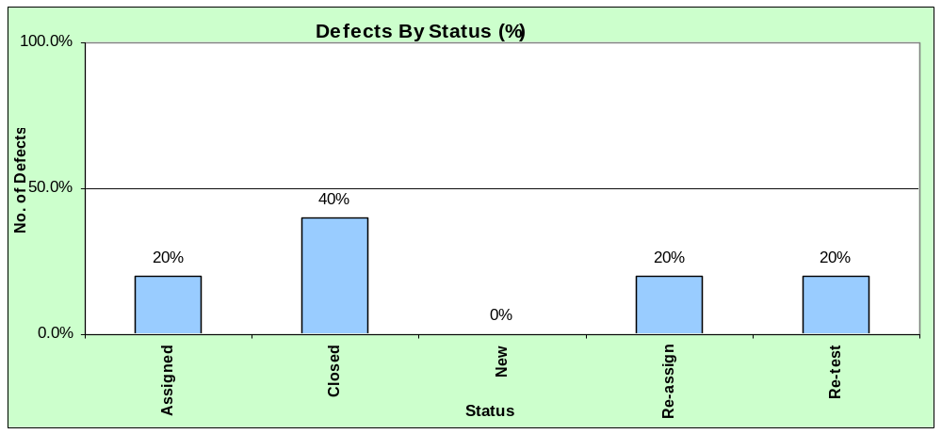

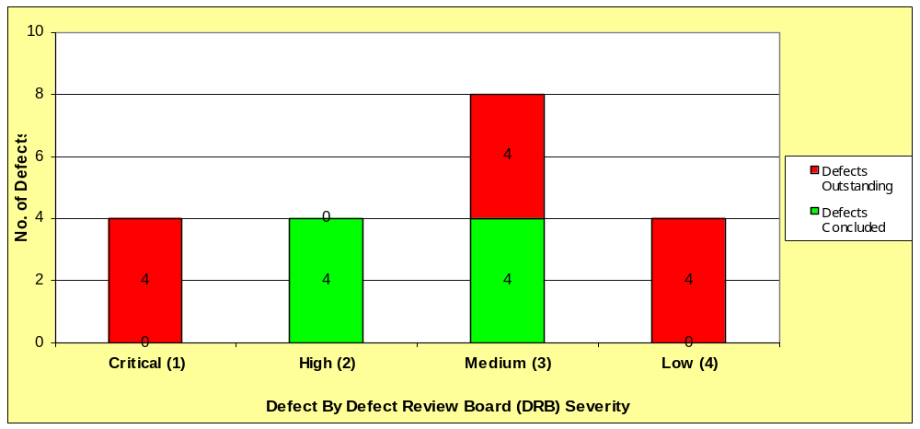

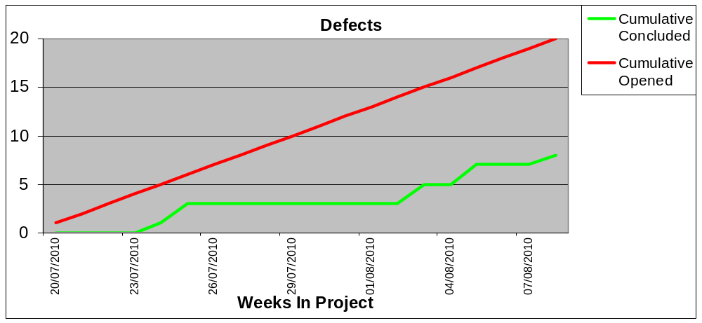

A detailed log of all defects raised can be found at Annex B.

Workarounds

<List any agreed / proposed workarounds including any documentation updates or where specific service desk involvement is required for example>

Residual Risks & Recommendations

The following is a list of outstanding risks together with specific recommendations if the final version of code tested in UAT were deployed to live as is:
Concerns | Recommendations
<List any outstanding risks if code were deployed to live – for example:  - insufficient system or UAT testing against final build (time runs out) may mean poor quality code is deployed…  - serious o/s defects may result in compromised functionality…  - build quality unstable…  - none identified  - etc…> | <List specific recommendations – for example:  - more testing…  - more fixing…  - liaise with business to better understand impact….  - none identified  - etc…>

<Choose either 10.2 or 10.3 and edit as appropriate>

<It is recommended that UAT is deemed to have passed and live deployment (or the next phase of testing) should commence as planned. Stated recommendations should be actioned as agreed by the project team.>

<It is recommended that UAT is deemed to have failed and live deployment (or the next phase of testing) should not commence. Stated recommendations should be actioned as a matter of priority and prior to live deployment.>

Abbreviations
Abbreviation | Description
BCS SIGIST | British Computer Society Specialist Group in Software Testing
DRB | Defect Review Board
HO DDaT | Home Office Digital, Data and Technology
HP QC | Hewlett Packard Quality Centre [Test Management Tool]
IEEE | Institute of Electrical and Electronic Engineers
ISO | International Standards Organisation
ISTQB | International Software Testing Qualifications Board
QA | Quality Assurance
SDS | System Design Specification
SME | Subject Matter Expert
SoR | Statement of Requirements
TES | Test Execution Schedule
UAT | User Acceptance Testing
UKBA | United Kingdom Border Agency
UI | User Interface

Annex A – Summary of Results

The following file details against each scenario executed:

- Whether it passed or failed;

- Any cross-references to defect numbers;

- If it failed in which cycle of testing it failed.

< Select Insert > Object> Create From File > Browse > Select File > Insert > Check ‘Display As Icon’ tick box (and change file name via change Icon Function if required)
Note: this should be the Test Execution Log worksheet from the UAT Execution Management Log>

A copy of this file can also be provided as a standalone product upon request.

Annex B – UAT Defect Log

The file provided below is the UAT Defect Log which contains details of all defects raised during UAT.

< Select Insert > Object> Create From File > Browse > Select File > Insert > Check ‘Display As Icon’ tick box (and change file name via change Icon Function if required)
Note: this should be the Defect Log worksheet from the UAT Execution Management Log>

A copy of this file can also be provided as a standalone product upon request.

Annex C – Detailed Test Scope

The attached file contains the detailed UAT Test Scope breakdown by requirement reference.

<Copy from UAT Test Plan>

< Select Insert > Object> Create From File > Browse > Select File > Insert > Check ‘Display As Icon’ tick box (and change file name via change Icon Function if required)

A copy of this file can also be provided as a standalone product upon request.

